A FIELD PROJECT REPORT ON
HUMAN IMPACT ON CLIMATE
Submitted
in partial fulfilment of the requirements for the award of the degree

BACHELOR OF TECHNOLOGY

in
COMPUTER SCIENCE AND ENGINEERING

By
G.ARAVIND | (241FA04184)
J.KUMAR SIVA SAI | (241FA04258)
BANADARUPALLI AKHIL | (241FA04337)
PASUPILETI SATHWIK | (241FA04E19)

Under the guidance of

Mr. Kumar Devapogu
Assistant Professor, CSE



Department of Computer Science and Engineering
School of Computing and Informatics
Vignan’s Foundation for Science, Technology and Research (Deemed to be University) Vadlamudi, Guntur, Andhra Pradesh-522213, India.
April – 2026



CERTIFICATE

This is to certify that the field project entitled “HUMAN IMPACT ON CLIMATE” being submitted by (G. Aravind & 241FA04184), (J. Kumar Siva Sai & 241FA04258), (B. Akhil & 241FA04337), And (P. Sathwik & 241FA04E19) in partial fulfilment of Bachelor of Technology in the Department of Computer Science and Engineering, Vignan’s Foundation For Science Technology & Research (Deemed to be University), Vadlamudi, Guntur District, Andhra Pradesh, India.
This is a bonafide work carried out by the aforementioned students under my guidance and supervision.

Guide

Project Review Committee | Head of the Department



DECLARATION

Date:

We hereby declare that our project work described in the field project titled (“HUMAN IMPACT ON CLIMATE”) is the result of our own efforts and investigations. The project is being submitted under the supervision of Mr. Kumar Devapogu in partial fulfilment of the requirements for the Bachelor of Technology (B. Tech) degree in the Department of Computer Science and Engineering at Vignan’s Foundation for Science, Technology & Research (Deemed to be University), Vadlamudi, Guntur, Andhra Pradesh.

G. ARAVIND | (241FA04184)
J. KUMAR SIVA SAI | (241FA04258)
BANADARUPALLI AKHIL | (241FA04337)
PASUPILETI SATHWIK | (241FA04E19)

 |  |  | 
 |  | 
 |  | 
 |  | 
 |  | 
 |  | 
 |  | 
 |  | 
 |  | 
 |  | 
 |  | 
7

CHAPTER 1

INTRODUCTION
Our aim is to understand and highlight the Human Impact on Climate. This topic focuses on how human activities such as industrialization, deforestation, excessive use of fossil fuels, and urbanization contribute to climate change. It explains the effects of greenhouse gas emissions on global warming, rising sea levels, and extreme weather conditions. The study also emphasizes the importance of sustainable practices, renewable energy, and environmental conservation to reduce negative impacts. Understanding human influence on climate helps create awareness and encourages responsible actions to protect the planet for future generations.

1.1 Problem Definition
Human activities such as pollution, deforestation, industrial growth, and excessive use of fossil fuels have a major impact on climate change. Although people are aware of environmental issues, there is still a lack of proper action and sustainable practices. This results in global warming, climate imbalance, and an increase in natural disasters. The absence of effective environmental management and public responsibility makes the situation worse. Therefore, it is necessary to understand and reduce human impact on climate to protect the environment and ensure a sustainable future.

1.2 Existing System
- Climate monitoring systems mainly focus on basic data collection such as temperature and pollution levels.
- Limited public awareness platforms explaining the impact of human activities on climate change.
- Lack of real-time tracking of carbon emissions and resource consumption at the individual level.
- Inadequate integration between environmental data, policy-making, and public participation.
- Minimal use of advanced data analytics to predict long-term climate impacts.
- Poor feedback and reporting systems to measure the effectiveness of climate control measures

1.3 Proposed System
- Monitors energy use, transportation, and resource consumption to assess human impact on climate.
- Tracks real-time carbon emissions from vehicles, industries, and urban areas.
- Supports multiple languages and regional measurement standards for global accessibility.
- Analyzes climate data and generates impact reports for better decision-making.
- Collects public feedback to evaluate environmental awareness and behavior.
- Integrates social media to spread climate information and sustainability practices
1.4 Literature Review
Many existing environmental monitoring systems focus mainly on collecting basic climate data, such as temperature, rainfall, and carbon emissions. However, studies show that there is a growing need for systems that provide personalized insights, real-time tracking, and interactive feedback for individuals and communities. Current solutions often lack multiregion support, detailed analytics, and tools to promote behavioral change. Our project aims to address these gaps by integrating real-time monitoring, data analytics, public feedback, and awareness tools into a user-friendly system that helps reduce human impact on climate.

CHAPTER 2
SYSTEM REQUIREMENTS

2.1 Hardware Requirements
- Computer/Laptop with minimum 4 GB RAM
- Processor: Intel i3 or equivalent
- Hard Disk: Minimum 20 GB free storage
- Monitor: Standard display (1366 × 768 resolution or higher)
- Keyboard and Mouse for input
- Internet Connection for research and data collection
2.2 Software Requirements
The SRS document outlines the functional and non-functional requirements of the system:
- Operating System: Windows 10/11, macOS, or Linux
- Presentation Software: Microsoft PowerPoint / Google Slides
- Word Processing Software: Microsoft Word / Google Docs
- Web Browser: Google Chrome, Mozilla Firefox, or Microsoft Edge
- PDF Reader: Adobe Acrobat Reader (optional for reading research papers)
Optional Tools
- Data Visualization Tools: Microsoft Excel or Google Sheets
- Image Editing Software: Canva / Photoshop (for diagrams and charts)

CHAPTER 3
SYSTEM DESIGNS

3.1 Modules of the System
The system is divided into the following modules:
1. User Interface Module
This module allows users to interact with the system.
Functions:
- Displays climate information
- Allows users to navigate between sections
- Shows charts, images, and reports
2. Data Collection Module
This module gathers climate-related data from different sources.
Functions:
- Collects information about pollution levels
- Stores data about deforestation and industrial emissions
- Updates climate statistics Data sources may include:
- Environmental research databases
- Government climate reports
- Scientific studies

3.2 UML Diagrams
- Use Case Diagram:
Shows interactions between user, admin, and the climate system. Users can view climate data, analyze human impact, and generate reports, while the admin updates and manages climate information.
- Class Diagram:
Describes classes such as User, ClimateData, EmissionData, Report, and Visualization and their relationships in the system.
- Activity Diagram:
Shows the flow of actions like user opening the system → selecting climate topic → system processing data → displaying results.
- Sequence Diagram:
Shows how system components interact over time when a user requests climate data and the system retrieves, processes, and displays it.

.

CHAPTER 4
IMPLEMENTATION
4.1 Sample code

<!DOCTYPE html>
<html lang="en">
<head>
<meta charset="UTF-8">
<title>Human Impact on Climate</title>
<style> body { font-family: Arial, sans-serif; margin: 0;
background-color: #eef6f7;
}

header {
background-color: #2e8b57;
color: white; text-align: center; padding: 20px;
}

nav {
background-color: #1f5f3a; padding: 10px; text-align: center;
}

nav a { color: white; margin: 0 15px; text-decoration: none; font-weight: bold;
}

section { padding: 20px;
}

.card { background: white; padding: 15px; margin: 15px 0; border-radius: 8px; box-shadow: 0 0 5px rgba(0,0,0,0.2);
}

footer {
background-color: #2e8b57; color: white; text-align: center; padding: 10px;
}
</style>
</head>

<body>

<header>
<h1>Human Impact on Climate</h1>
<p>Understanding how human activities affect our planet</p>
</header>

<nav>
<a href="#causes">Causes</a>
<a href="#effects">Effects</a>
<a href="#solutions">Solutions</a>
</nav>

<section id="causes">
<h2>Causes</h2>

<div class="card">
<h3>Deforestation</h3>
<p>Cutting down forests reduces the Earth's ability to absorb carbon dioxide.</p> </div>

<div class="card">
<h3>Burning Fossil Fuels</h3>
<p>Coal, oil, and gas release greenhouse gases that trap heat in the atmosphere.</p> </div>

<div class="card">
<h3>Industrial Pollution</h3>
<p>Factories release harmful gases that contribute to climate change.</p> </div>

</section>

<section id="effects">
<h2>Effects</h2>

<div class="card">
<h3>Global Warming</h3>
<p>Average global temperatures are rising due to increased greenhouse gases.</p> </div>

<div class="card">
<h3>Melting Ice Caps</h3>
<p>Rising temperatures cause glaciers and polar ice to melt.</p> </div>

<div class="card">
<h3>Extreme Weather</h3>
<p>Climate change increases floods, droughts, and storms.</p> </div>

</section>

<section id="solutions">
<h2>Solutions</h2>

<div class="card">
<h3>Renewable Energy</h3>
<p>Using solar, wind, and hydro power reduces carbon emissions.</p>
</div>
<div class="card">
<h3>Plant More Trees</h3>
<p>Reforestation helps absorb carbon dioxide from the atmosphere.</p> </div>
<div class="card">
<h3>Reduce Waste</h3>
<p>Recycling and reducing plastic helps protect the environment.</p>
</div>
</section>

<footer>
<p>Project: Human Impact on Climate</p>
</footer>
</body>
</html>

Explanation
- Declares the HTML5 document and sets the language to English.
- Includes CSS styling to design the webpage layout and appearance.
- Displays a title and header related to Human Impact on Climate.
- Contains a navigation menu with sections like Causes, Effects, and Solutions.
- Shows information about human activities affecting the climate (deforestation, pollution, fossil fuels).
- Displays the effects of climate change such as global warming, melting ice caps, and extreme weather.

CHAPTER 5

RESULTS
5.1 Output Screens

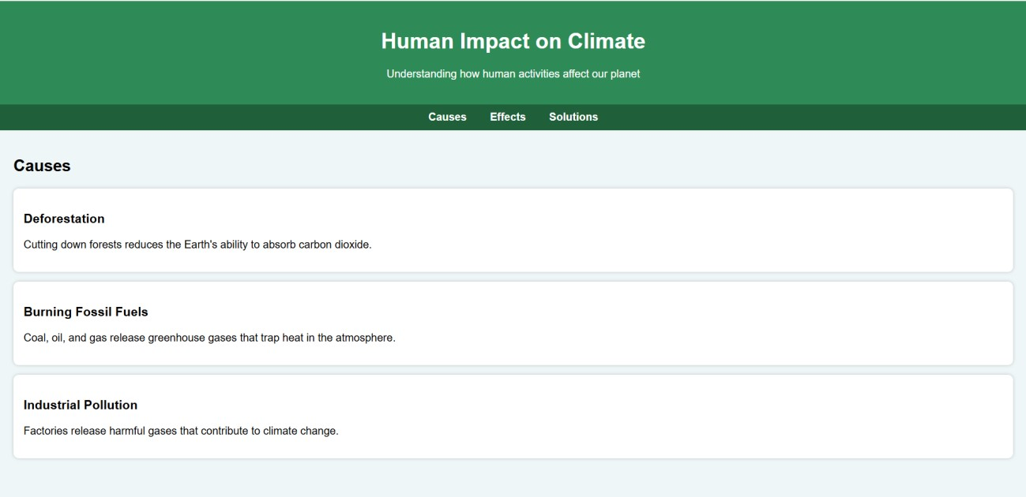

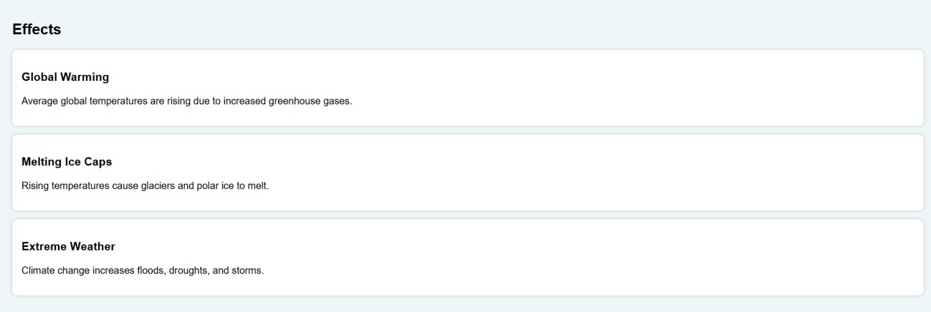
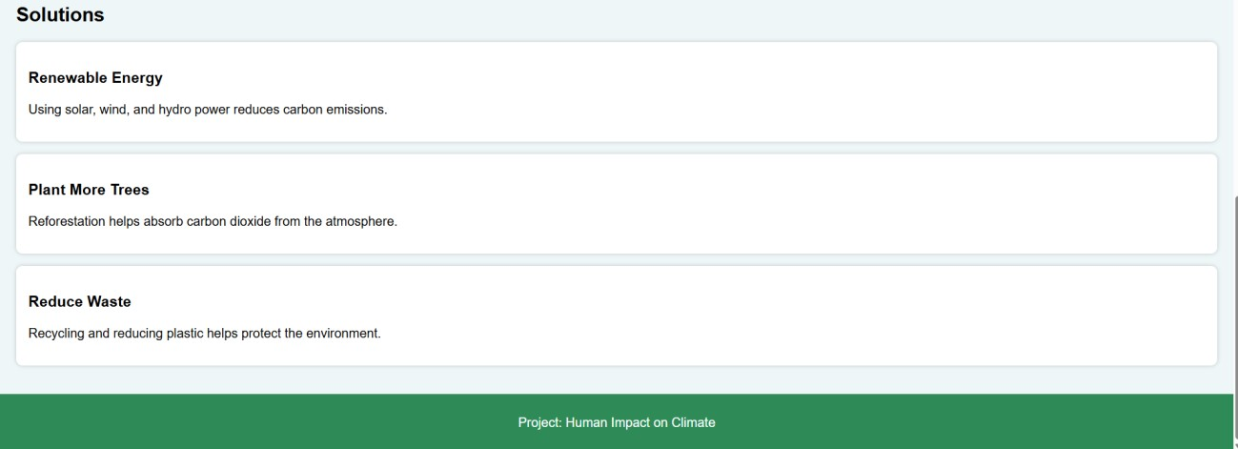

CHAPTER 6
CONCLUSION

Human activities have significantly altered the Earth’s climate system, primarily through the emission of greenhouse gases such as carbon dioxide, methane, and nitrous oxide. Industrialization, deforestation, urbanization, and excessive use of fossil fuels have accelerated global warming, leading to rising temperatures, melting glaciers, sea-level rise, and extreme weather events.
The evidence clearly shows that climate change is not a distant threat but a present reality affecting ecosystems, economies, and human health worldwide. However, the situation is not irreversible. By adopting sustainable practices, transitioning to renewable energy sources, improving energy efficiency, and promoting environmental awareness, humanity can reduce its impact on the planet.

CHAPTER 7
REFERENCES

- Intergovernmental Panel on Climate Change (IPCC). Climate Change 2023: Synthesis Report.
- National Aeronautics and Space Administration (NASA). Global Climate Change: Vital Signs of the Planet.
- National Oceanic and Atmospheric Administration (NOAA). Climate Change Indicators.
- United Nations Environment Programme (UNEP). Emissions Gap Report.
- World Health Organization (WHO). Climate Change and Health.
- The Sixth Extinction – Elizabeth Kolbert
- This Changes Everything – Naomi Klein

